Day 5 Assignment 1
Name: Mriganka Patra
Email: Mriganka.patra@cognizant.com

Task 1: Select a moderately complex web application module.
- Include login, product selection, cart management, address entry, payment, and confirmation.
Test Scenarios
# | Scenario Name | Description
1 | Login with valid credentials | Ensure registered users can log in successfully
2 | Login with invalid credentials | Check error handling for wrong inputs
3 | Add product to cart | Verify user can select and add item to cart
4 | Edit cart (quantity, remove items) | Ensure cart supports item quantity update and deletion
5 | Apply discount coupon | Validate coupon code logic and discounts applied
6 | Proceed to checkout | Confirm cart details before checkout
7 | Enter delivery address | Ensure valid address can be entered or selected
8 | Select payment method | Test availability of payment modes (Card, UPI, COD)
9 | Payment gateway success flow | Verify successful payment transaction
10 | Payment gateway failure flow | Check system’s response on failed payment
11 | Order confirmation page | Confirm receipt is shown with correct details
12 | Email confirmation | Ensure confirmation email is triggered post-order

Task 2: Create 10-12 high-level test scenarios covering functional, UI, security, and integration aspects.
Test Case – Add Product to Cart
- Test Case ID: TC_005
- Scenario: Add product to cart
- Preconditions:
  - User is logged in
  - Product listing is available
- Test Steps:
  - Navigate to product listing
  - Select a product
  - Click "Add to Cart"
- Expected Result: Product is added to cart and cart icon is updated
- Postconditions: Product remains in cart on page reload
- Priority: High
- Severity if Failed: Critical

Task 3: Write detailed test cases for each scenario, including:
- Preconditions, test steps, expected results, postconditions
- Priority and severity classification

- Open Jira
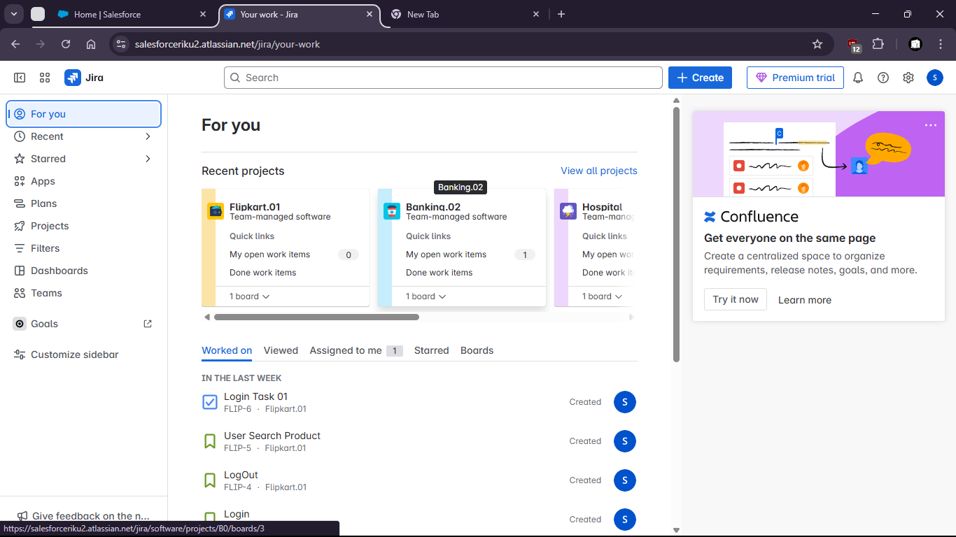
- Create Epic
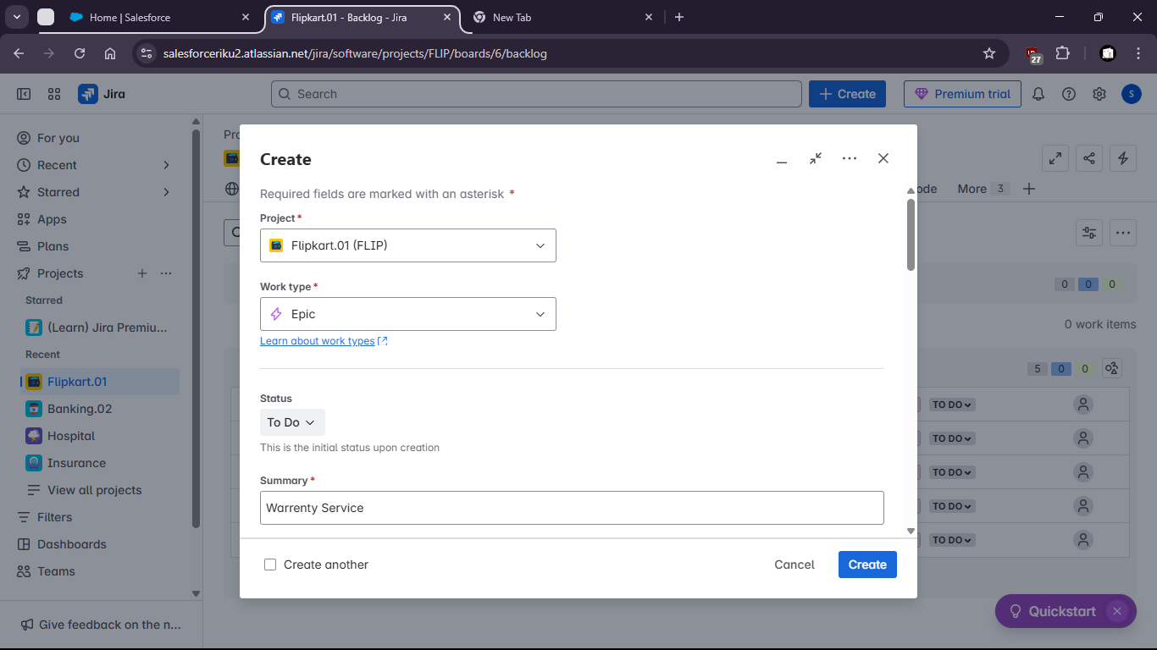
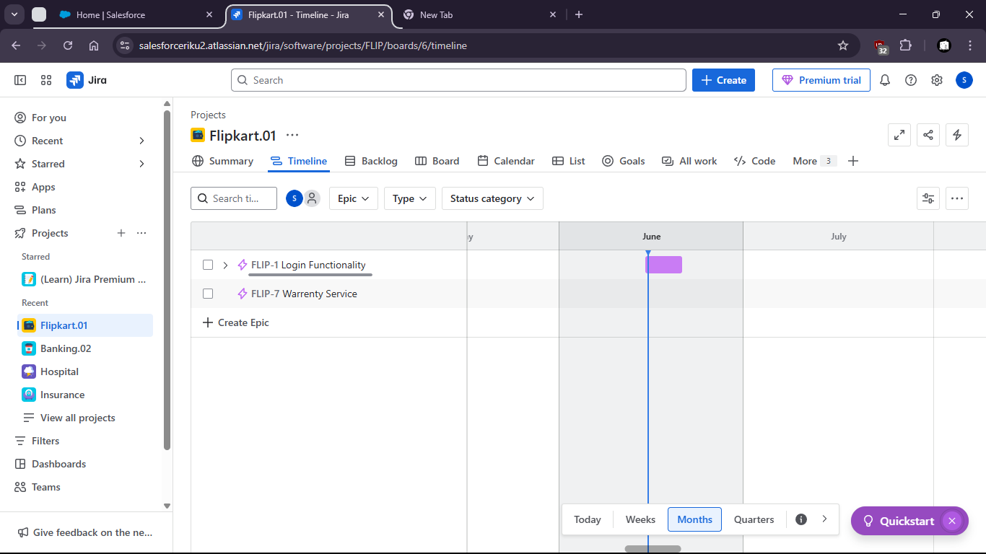
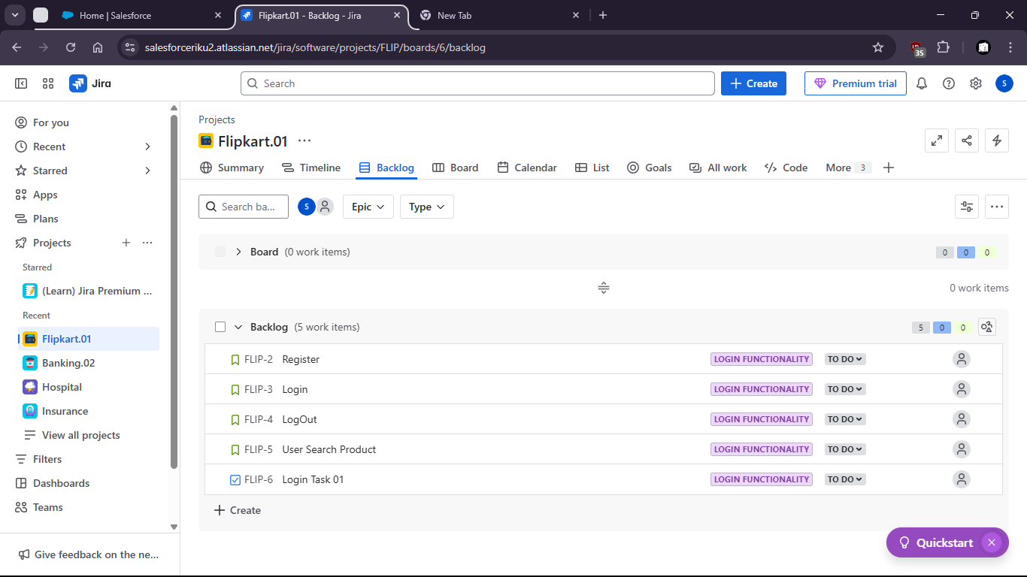

Task 4: Execute all test cases:
- Record results: Pass, Fail, Blocked
- Capture evidence for failed cases

- Go to project settings
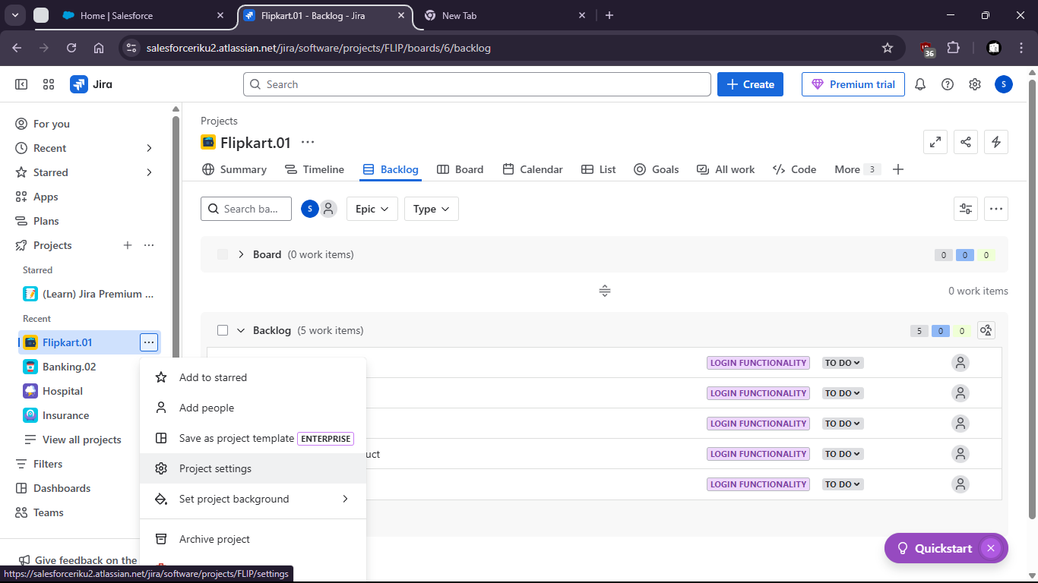
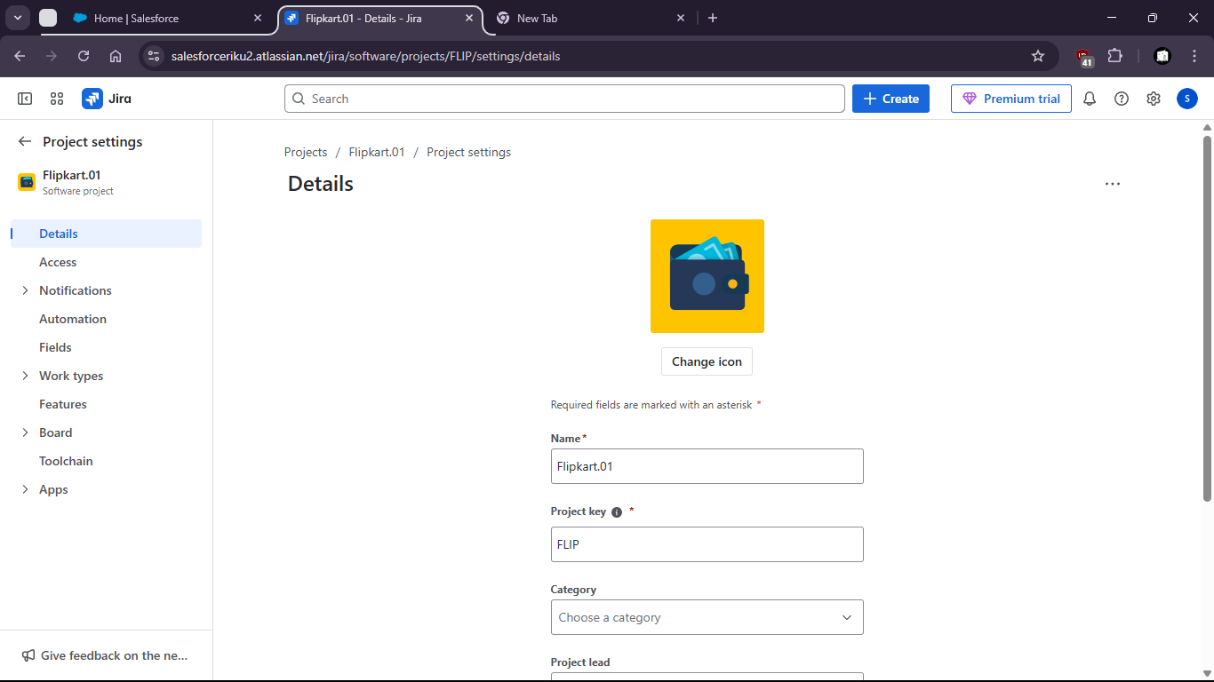
- Then open issue types to view all available types of issues
- Create a new task under the Project
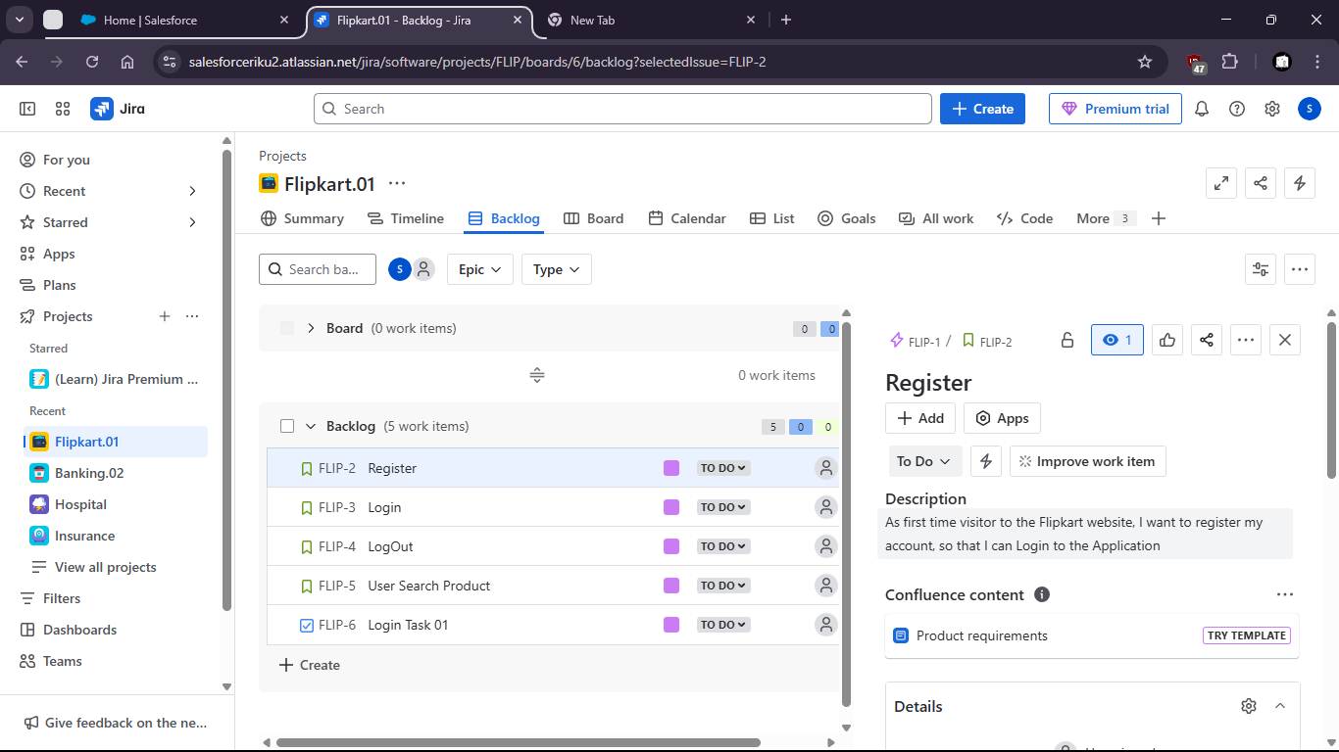
- View the task

- Add some description
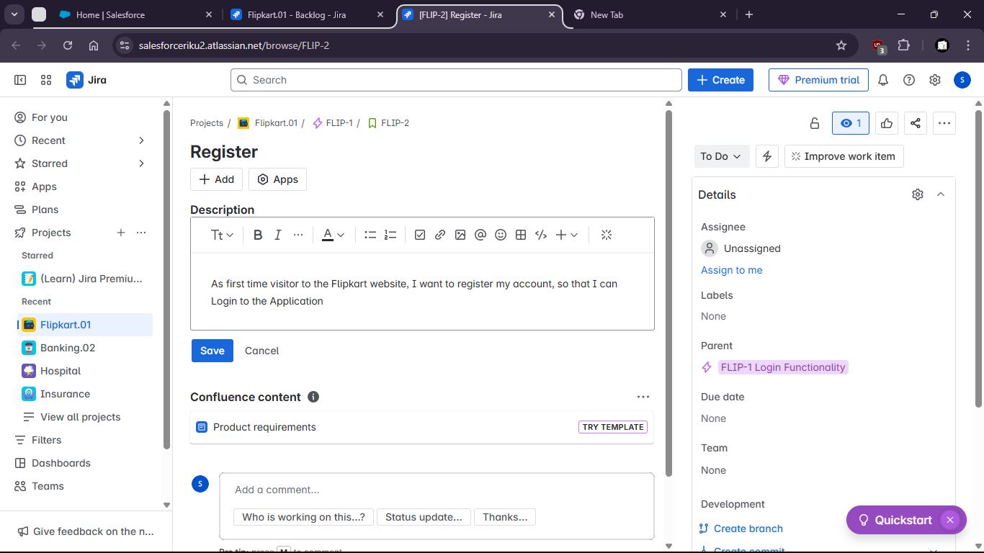

Test Summary Report
Section | Details
Total Test Cases Executed | 12
Passed | 10
Failed | 2
Blocked | 0
Total Bugs Logged | 5
Bug Severity Distribution | 2 Critical, 2 Major, 1 Minor
Unresolved Issues | Bug #001 (Cart issue), Bug #004 (Payment timeout)
Recommendation | Sign-off Deferred until cart and payment issues are resolved

Task 5: Report atleast 5 bugs using a tool like JIRA or simulate the report manually:
- Include defect details, repro steps, environment, screenshots, and linked test case ID

Bug Report 1
- Bug ID: BUG-001
- Title: Cart icon not updated after adding product
- Linked Test Case: TC_003 (Add product to cart)
- Severity: High
- Priority: High
- Environment: Chrome v123, Windows 10
- Steps to Reproduce:
  - Log in as a registered user
  - Add a product to the cart
- Expected Result: Cart icon should update with the correct item count
- Actual Result: Cart icon remains unchanged (shows 0 items)
- Screenshot: cart_bug.png (Attach in JIRA)
- Status: Open

Bug Report 2
- Bug ID: BUG-002
- Title: Payment gateway timeout error not handled gracefully
- Linked Test Case: TC_010 (Payment gateway failure flow)
- Severity: Critical
- Priority: High
- Environment: Firefox v115, Ubuntu 22.04
- Steps to Reproduce:
  - Proceed to payment
  - Select UPI and wait for timeout (do not complete transaction)
- Expected Result: App should show “Payment failed, please try again”
- Actual Result: Blank white screen is shown
- Screenshot: payment_timeout.png (Attach in JIRA)
- Status: Open
Bug Report 3
- Bug ID: BUG-003
- Title: Confirmation email not triggered after successful order
- Linked Test Case: TC_012 (Email confirmation)
- Severity: Major
- Priority: Medium
- Environment: Edge v110, Windows 11
- Steps to Reproduce:
  - Place a successful order
  - Check registered email inbox/spam
- Expected Result: Email with order receipt should be received
- Actual Result: No email received after 15 minutes
- Screenshot: no_email_confirmation.png (Attach in JIRA)
- Status: Open

Bug Report 4
- Bug ID: BUG-004
- Title: User is allowed to proceed to checkout with empty cart
- Linked Test Case: TC_006 (Proceed to checkout)
- Severity: Major
- Priority: High
- Environment: Chrome v123, macOS 14
- Steps to Reproduce:
  - Log in and empty the cart
  - Click on “Proceed to Checkout”
- Expected Result: User should be redirected to cart with warning
- Actual Result: Checkout page opens with empty product summary
- Screenshot: empty_checkout.png (Attach in JIRA)
- Status: Open

Bug Report 5
- Bug ID: BUG-005
- Title: Login with invalid credentials does not show error message
- Linked Test Case: TC_002 (Login with invalid credentials)
- Severity: Minor
- Priority: Medium
- Environment: Safari v17, iOS 16
- Steps to Reproduce:
  - Enter incorrect email/password
  - Click on “Login”
- Expected Result: Error message like “Invalid credentials” should appear
- Actual Result: No message shown, but login doesn’t proceed
- Screenshot: invalid_login_no_msg.png (Attach in JIRA)
- Status: Open

Task 6: Track the status of each defect from Open -> Verified or Closed.
  - Go to Jira dashboard

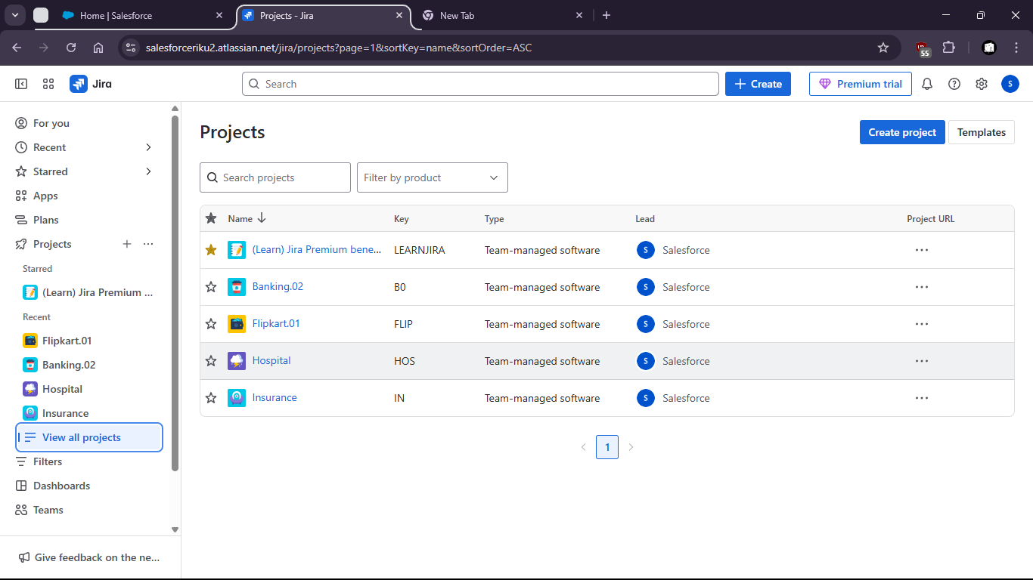

Click on create to create a bug and then update status to done

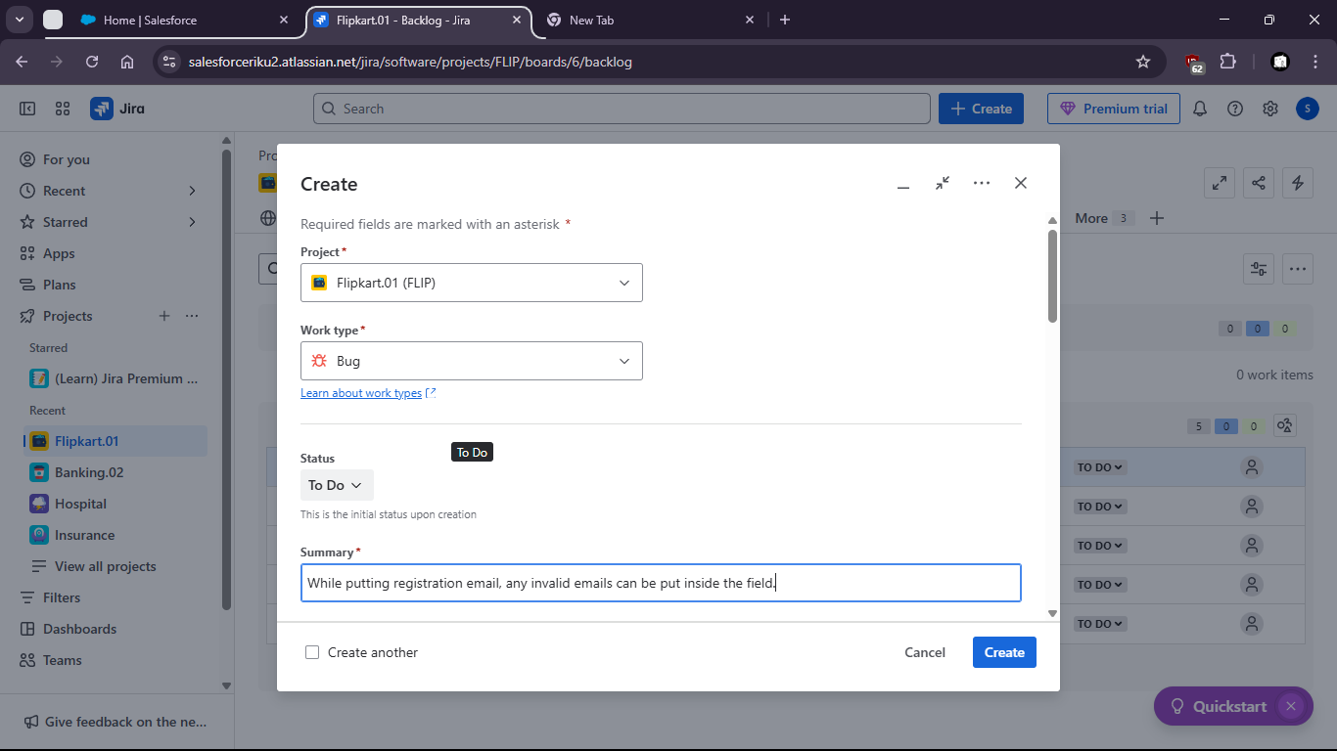

  - add parent
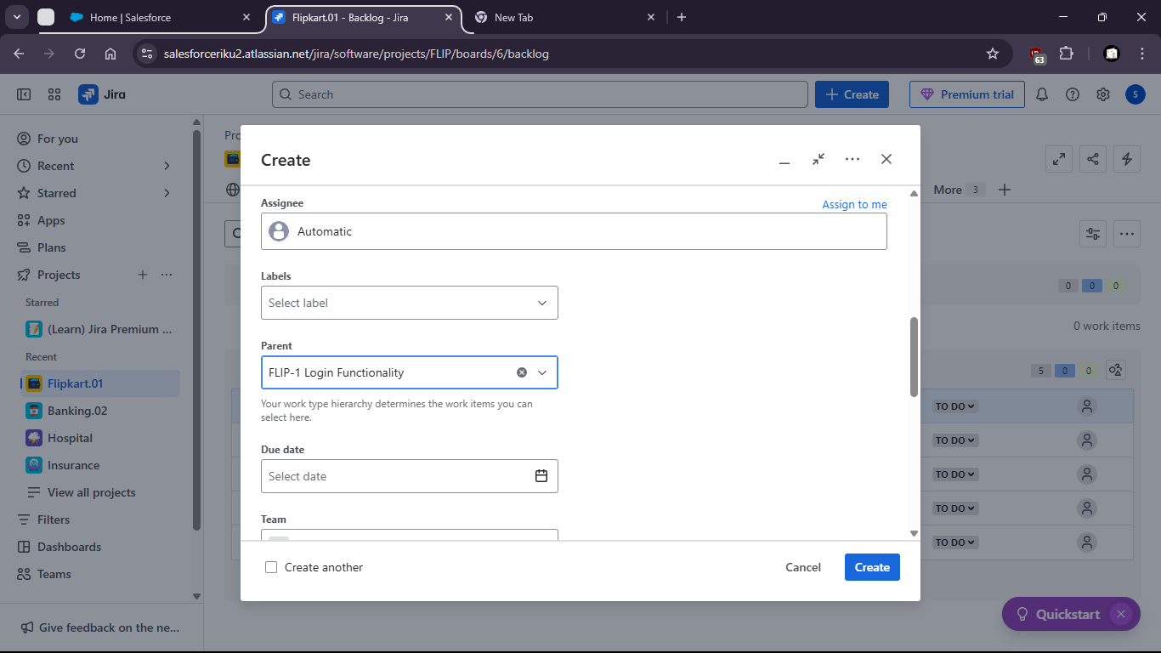

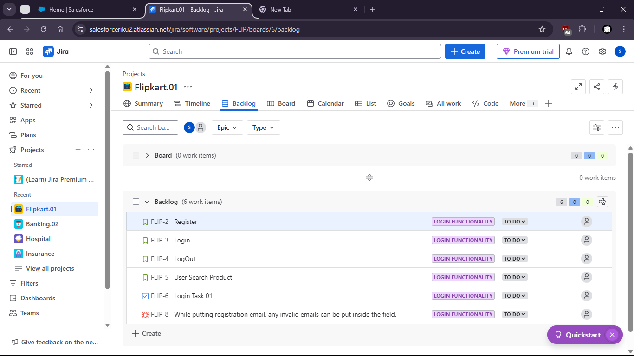

Task 7: Draft a test summary report including:
- Total tests, execution results, bug metrics, risk assessment, unresolved issues
- Recommendation for test sign-off with justification

Test Summary Report
Project: Flipkart 01
Module: Checkout and Cart Functionality
Test Lead: Mriganka Patra
Test Cycle Duration: June 10 – June 15, 2025
Test Environment:
- OS: Windows 10 / macOS 14 / Ubuntu 22.04
- Browsers: Chrome 123, Firefox 115, Safari 17
- Backend: Node.js + MongoDB
- Frontend: React v18

Test Execution Summary
Metric | Count
Total Test Cases Executed | 12
Passed | 9
Failed | 3
Blocked | 0
In Progress | 0
2. Bug Metrics
Severity | Open | Closed | Verified | Total
Critical | 1 | 0 | 0 | 1
High | 0 | 1 | 2 | 3
Medium | 0 | 2 | 0 | 2
Low | 0 | 0 | 0 | 0
Total | 1 | 3 | 2 | 6
Open Defect:
- BUG-002 – Payment timeout error not handled (Severity: Critical) – In Progress

3. Risk Assessment
Risk Area | Description | Mitigation
Payment Handling | Timeout not properly caught → risk of revenue loss | Bug fix in progress; retesting scheduled
Email Confirmation | Initially failed; now fixed | Regression tests passed
UI Cart Logic | Critical cart icon logic fixed | Verified on all browsers

4. Unresolved Issues
Bug ID | Title | Severity | ETA
BUG-002 | Payment timeout error not handled | Critical | Fix deployed to staging; retest on June 16

